COMP 3023 – Design Patterns with C++ (SP2 2023)

Course | Design Patterns with C++
Name | Gitae Bae
Email | baegy002@mymail.unisa.edu.au
Identifier | 110310861
Date | Sunday, 11/06/ 2023

Assignment2 – Programming Assignment 2: Patient Management System Partial Implementation

[Gitae Bae]
[11/06/2023]

Contents

Design Structure with UML diagram …………………………………………….………………………………………..….…3

Functional requirement FR1: Load patients from file…………………………………………….……………….……..4

Functional requirement FR2: calculate the patient alert levels………………………………………………………5

Functional requirement FR3: calculate the alert level for all diseases a patient has…………………….…6

Functional requirement FR4: alert the hospitals and GPs ……………………………………………………………...8

Design Structure with UML diagram

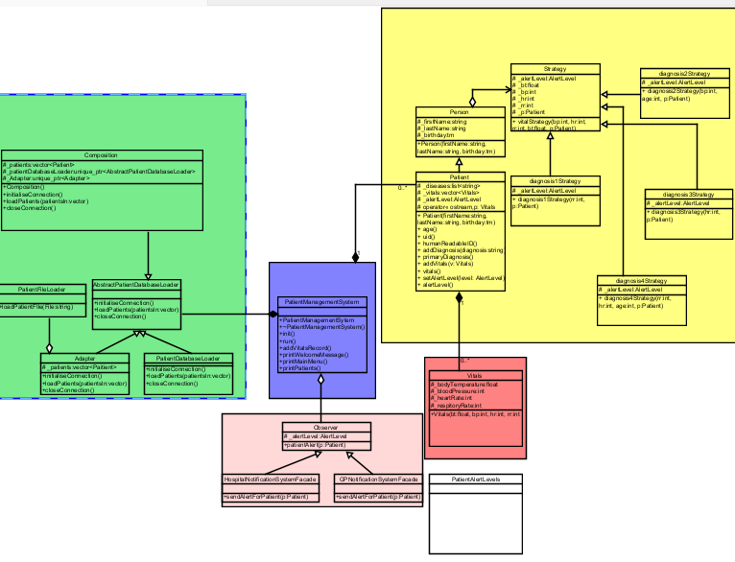

Figure1: Whole Design Structure

Functional requirement FR1: Load patients from file
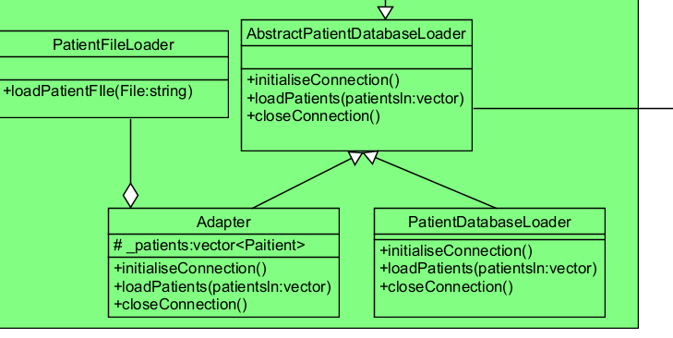
Figure 2: Adapter Pattern

Design Patterns: Adapter Pattern
PatientFileLoader class to load patient data from the file using Adapter design pattern. So, consider what design pattern is able to be used to address this problem and get the design class diagram to factor in the pattern and how to complete the design changes to address the problem. I used Adapter class using AbstractPatientDatabaseLoader to change the interface of PatientFileLoader.

How it works:
- Connect initialiseConnection(), closeConnection(), patientLoad().
- Patient.txt file connected to Adapter.cpp file.
- Patient file load can be executed in PatientFileLoader.
- PatientFIleLoader can read the patient detail information and save it in vector.

Git commits:
- I first added Adapter class in commit 612763.
- I fixed something in commit 8a0e00b.

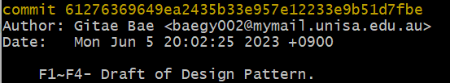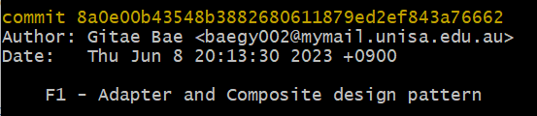

Functional requirement FR2: calculate the patient alert levels
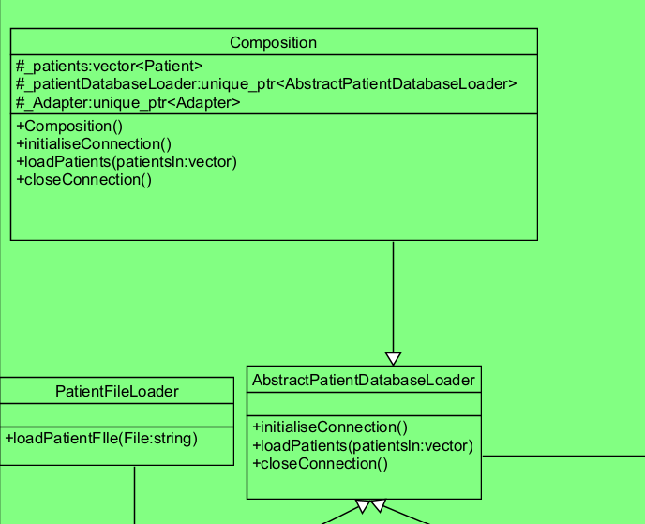
Figure3: Composite Pattern

Design Patterns: Composite Pattern
The system has to use the correct algorithm for calculating a patient’s alert level dependent on the patient’s primary disease. Each patient uses an algorithm dependent, and the alert level should be calculated using Vitals and not be calculated for patient data loaded and consider what design pattern and complete the design changes. Composite file can load AbstractPatientDatabaseLoader to process data and file togaether.

How it works:
- Connect initialiseConnection(), closeConnection(), patientLoad().
- Connect patientLoad using AbstractPatientDatabaseLoader.cpp to load the patient.
- Connect patientLoad using Adapter.cpp
- The PatientManagementsystem call composite file and load, initial, close function.

Git commits:
- I first added Composite class in commit 612763.
- I fixed something in commit 8a0e00b.


Functional requirement FR3: calculate the alert level for all diseases a patient has
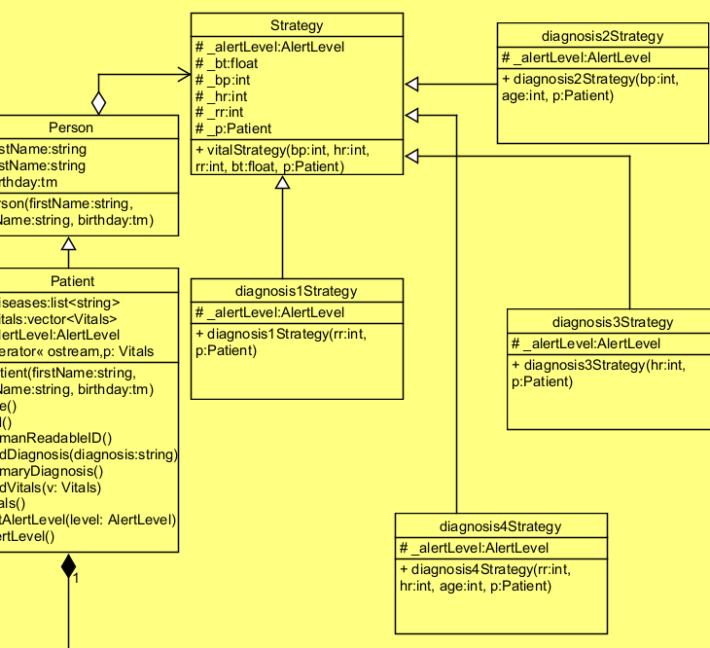
Figure4: Strategy Pattern

Design Patterns: Strategy Pattern
A patient has more than one disease. The system has to calculate a patient’s highest alert level dependent on all their disease. Each patient use all algorithms and alert level must be the highest level calculated using Vitals or not be calculated for historical patient data loaded from a database or file using strategy pattern. Consists of Strategy pattern are ‘Strategy’, ‘Diagnosis1Strategy’, ‘Diagnosis2Strategy’, ‘Diagnosis3Strategy’, ‘Diagnosis4Strategy’.

How it works:
- Include other whole strategy classes such as ‘Diagnosis1Strategy’, ‘Diagnosis2Strategy’, ‘Diagnosis3Strategy’, ‘Diagnosis4Strategy’.
- Check the patients have what diseases from stored data
- AlertLevel - A patient defaults Green alert level unless their vitals raise their level.

Git commits:
- I first added Strategy class in commit 612763.
- I created strategy classes in commit in 362ef7.
- Other commits include: e58965, f34ec39, 1692f2, b6187c, 873ef2.

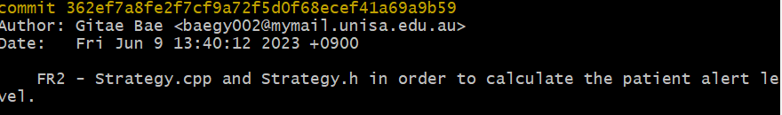
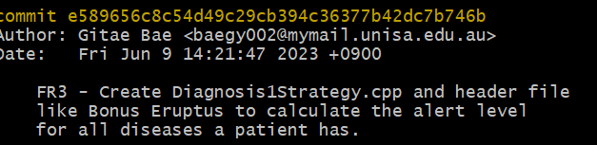
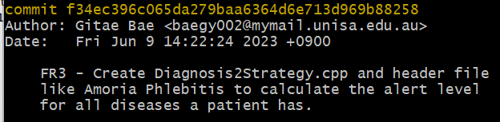
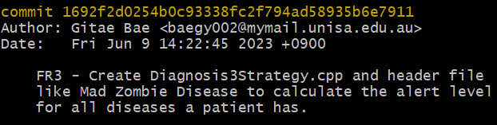
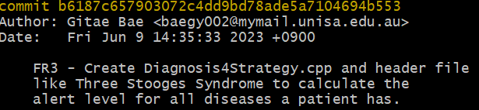
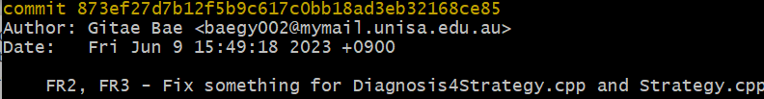

Functional requirement FR4: alert the hospitals and GPs
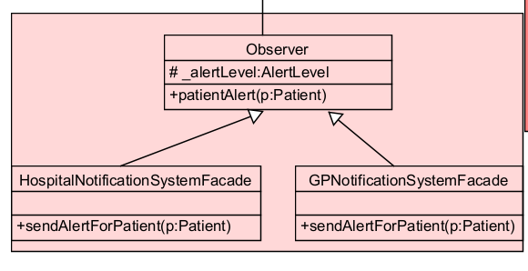
Figure5: Observer Pattern

Design Patterns: Observer Pattern
System should check stakeholders when a patient’s alert level reaches Red. Interfaces are provided that is able to alert hospitals and GPs of concerning patients. Connect these facades to changes in patient alert levels. This notification has to happen immediately when a patient’s alert level changes using Observer design pattern.

How it works:
- Using patientAlert() in observer class, this notification has to happen immediately when a patient’s alert level changes using Observer design pattern.
- System should check stakeholders when a patient’s alert level reaches Red. System should display a message to the GP and hospital using GPNotificationSystemFacade class and HospitalNotificationSystemFacade class.

Git commits:
- I first added Observer class in commit 612763.
- I also fixed something in commit c39e7a.

